05th October 2026

LETTER OF RECOMMENDATION

I am writing to you with regards to Mr. Kishore Kumar L who has requested that I write a letter of recommendation on his behalf. I support his decision and strong desire to take his dedication and skill to the next level.

Kishore Kumar has worked for the duration of May 2026 to July 2026 as an Intern in our organization. Over the time that I have known Kishore Kumar, he has consistently performed his duties with competence and often goes the extra time, doing more than expected.

Kishore Kumar is an excellent problem solver. In addition, He is an excellent communicator and has the skills and personally needed to be a leader. He has been exposed to different processes and found to be Punctual, Hard Working and Inquisitive.

Your program will benefit by training and learning his technical skills to become a world-class professional. and I hope that his recommendation will have your favorable consideration.

For Gradtwin Services (OPC) Private Limited
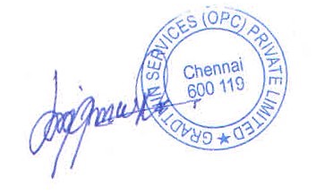

Kanishrajiah Durairaju

Manager - Human Resource

